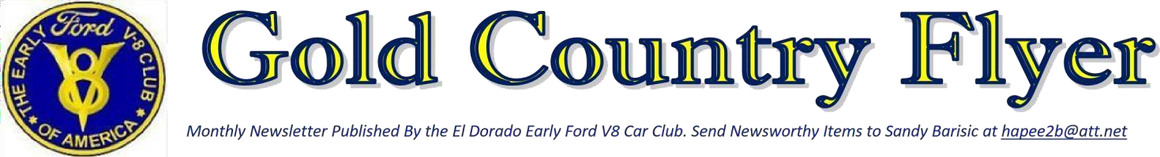

Regional Group #130 Volume 36 Issue #2 February 2024
Volume 36 Issue # 2 February 2024

Mission Statement
The El Dorado Early Ford V8 Car Club is based in El Dorado County, California and is dedicated to the restoration and preservation of Ford, Mercury, and Lincoln vehicles designed and built by the Ford Motor Company from 1932 to 1953. Meetings are held on the first Thursday of each month. Locations change so check the newsletter for location.

President’s Dean’s Message
Welcome to the February monthly newsletter of the El Dorado Early Ford V8 Club. The car show calendar is starting to come together getting the car file included is giving us fits so please look for it under a separate email. I’ll try and keep it updated as best I can, if you know of a show and don’t see it on the list please let me know so I can include it. Don’t forget the club meeting March 4th at Colina de Oro in Diamond Springs. Currently I’m thinking of having our June Meeting at the Forester in Camino, should be good weather and good daylight for our travels home. Can’t wait for spring so we can get together and take day trips in our beautiful part of this state. Targets include Plymouth wine country, El Dorado’s produce farms, and California Automobile Museum. Very open to other destinations,. Stay Safe and Happy out there. Dean
Meeting Minutes Early Ford V8 Club

The El Dorado Early Ford V8 Club held our February meeting at the Breakroom in Shingle Springs on Thursday, February 1st. There were 16 members in attendance and no guests. The meeting was called to order at 6:36pm by President Dean. A vote was taken to approve the minutes from the January meeting as posted in the newsletter. Jo gave the treasurer report, noting the payout for our website domain for 2 years as only expense this month. Sunshine Judi reported most members doing well, with Jim back on track after kidney stones. Art is still available to assist anyone wishing to purchase any accessories, such as hats, shirts, jackets, etc. Jerry Lucas still has car club plaques available to purchase. We have been unable to locate a copy of our club’s by-laws, so was discussed and decided to use the National Club’s By-laws as our guideline. Dean has put together a form that we can pass out at car shows and gatherings to help expand our membership. Dean will be passing copies out to club members. September 28th will be the Cops & Rodders car show, add to your calendar. Also, Kim Hopwood will check with Union Mine High School for their car show date. It was discussed about possible club cruises to Apple Hill, a winery, or museum. If you have any suggestions, please share them at the next meeting. A vote was taken, and it was unanimous to place Rex & Sue as honorary members. The ladies’ luncheon is scheduled for Monday, February 12th at the Old Town
Grill on Main Street in Placerville at 11:30am. The men’s luncheon is scheduled for Wednesday, February 21st at the Brick Oven Pub on Placerville Drive, at 11:45am.
We have two birthdays in February: Jon Hopwood on the 11th, and Judy Madison on the 18th. There are no anniversaries in February. March’s monthly meeting will be
held at Colina de Oro in Diamond Springs on
Thursday, March 7th at 5:30pm. February’s breakfast will be held at the Golden Waffle at 9am on February 17th. March’s breakfast will be at the Train Station in Shingle Springs, on Saturday March 16th at 9am.
The meeting was adjourned at 7:01pm.
Submitted by Secretary Patty Plant

Meeting March 7th & April 4th
March 7 at Colina de Oro Diamond Springs

April 4 at Pizza Plus Placerville

Breakfast Saturday March 17th

3rd Saturday of month

The club breakfast March 17th at 9:00am.

Train Station in Shingle Springs
2024 Breakfast Schedule
We are trying to have breakfast on the
3rd Saturday of the month.
March Hopwood’s
April: Jim Moore
May: Plant’s
June Barbara & Don Erb
July:
August: Art & Michelle Hardie
Sept: Sandra Morgan
October:
November: Milo & Jo

Birthdays and Anniversaries
March Rex Roden 25th
No Anniversary

Christmas Party December 7, 2024

Forester Camino 11 am bring $20 gift exchange

Club Picnic Saturday May 4, 2024

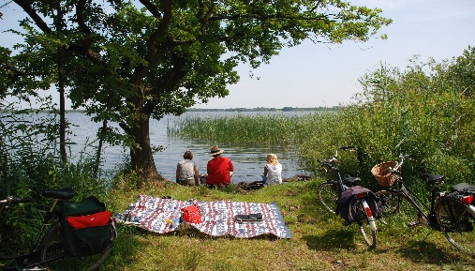

Car of the Month

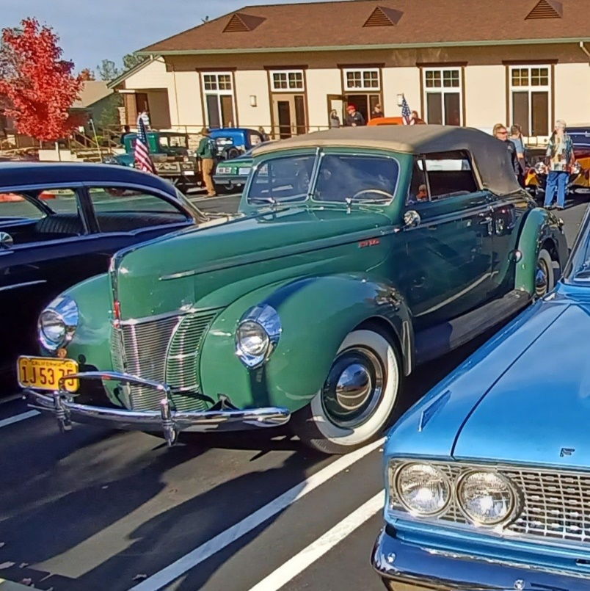

February 2024 Car of the month! Dan and Gerry Schwartz 1940 Deluxe Convertible

Ladies Luncheon February

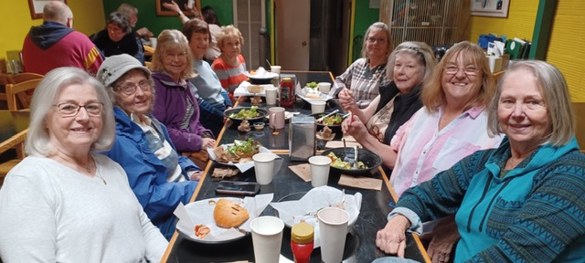

The ladies’ luncheon was held at the Old Town Grill in Placerville on Monday, February 12th. We had 9 members there, food was good, small area so a little noisy; but everyone had a great time.

Meeting February 1st

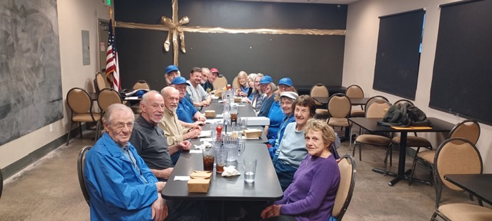

February 1st club meeting at the Breakroom

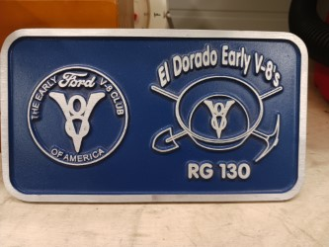

Contact Jerry Lucas or Dean if you would like to purchase 1.
$27.50 is what Jerry paid for them in a lot of 10 he's only asking what he paid.

Men’s Luncheon

Ok so we had such a good time at lunch Dean forgot to get a picture taken.

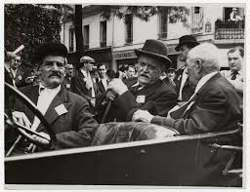

Upcoming Cruises.
Topic for discussion bring your calendars to the March meeting.
June 13, 20, 27 Sacramento Auto Museum
July Boa Vista picnic BYOL Bring your own lunch.
August Gold Bug Park? BYOL Bring your own lunch.
September Winery open

Hardie’s Car for Sale I sadly am offering my ‘35 Ford PU for sale which I’ve had since 1989. The 1st restoration was completed in 1997 with a Flathead/C4 auto. I upgraded in 2006 to a Hipo Cobra 289 and more. The engine is a Hipo mechanical lifter 289 out of an original Shelby small body Cobra. The trans is still a Ford C4. Rear end is Ford 9”, I think 3.70 gearing. In 2006 I upgraded the front end to disc brakes & mono leaf spring. The rear has twin parallel leaf springs. If anyone is interested, please have them contact me for more detailed info. I am asking $55K
Art Hardie 530-409-5120 hangtownace@sbcglobal.net
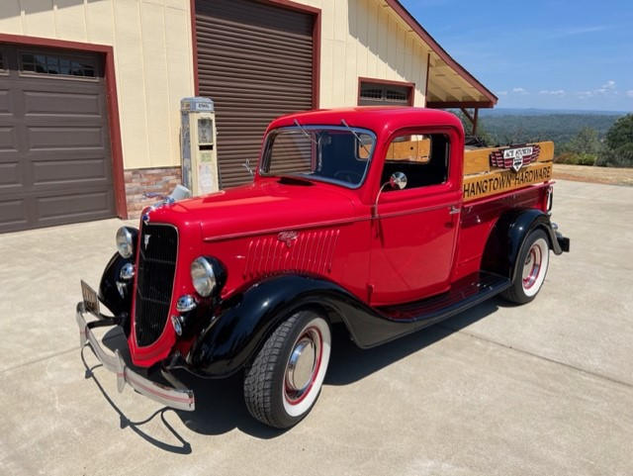

Sunshine Sunshine


Well, it seems like everyone who responded are doing well. I received responses back from: Patti & Dean (with an exception) hope your back is better Dean; Gerry & Judy; Diane & Don; Sandra Morgan; Kim & Jon; Howard & Judy; Dave & Karen; Art & Michelle and Bud and I.
I hope all that did not reply are also doing well.

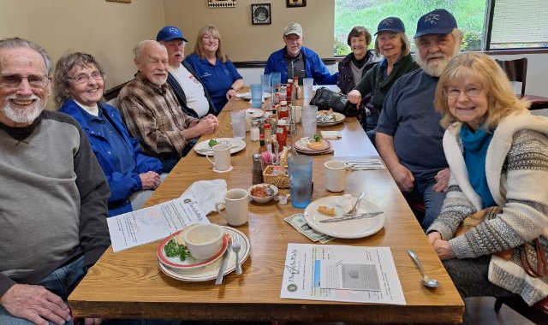
Breakfast 10 club members enjoying great food and friends.

Got something to sell? Post it here for free.

