

Regional Group #130 Volume 36 Issue #4 April 2024
Volume 36 Issue # 2 February 2024

Mission Statement
The El Dorado Early Ford V8 Car Club is based in El Dorado County, California and is dedicated to the restoration and preservation of Ford, Mercury, and Lincoln vehicles designed and built by the Ford Motor Company from 1932 to 1953. Meetings are held on the first Thursday of each month. Locations change so check the newsletter for location.

President’s Dean’s Message

Welcome to the March monthly newsletter of the El Dorado Early Ford V8 Club. The car show calendar is really starting to come together. It’s up to two pages now but I’ve included some fun Flathead events just in case someone has an interest. One example is the Lucas’s and Plants are headed to Woody’s in the Valley April 26-28. Getting the car show file included in the newsletter is giving us fits so please look for it under a separate email. I’ll try and keep it updated as best I can, if you know of a show and don’t see it on the list, please let me know so I can include it.

Don’t forget the club meeting April 4th at Pizza Plus in Placerville. I’m thinking of having our June Meeting at the Forester in Camino, should be good weather and good daylight for our travels home. Can’t wait for spring so we can get together and take day trips in our beautiful part of this state. First up in my mind is maybe a BYOPB (Bring Your Own Picnic Basket) to Boa Vista or Gold Bug Park or a trip to the Auto Museum before it gets too hot. Other targets for later in the year include Plymouth wine country, El Dorado’s produce farms, and wine country. Very open to other destinations,
FYI the Plants have signed up for the following Shows Thunder in the Park 8 June, The Italian Car Show 29 June and have my finger on the trigger for the Valley Springs Car Show 17th of May. Hope to have some fellow club members to travel with.
Stay Safe and Happy out there. Dean
Meeting Minutes Early Ford V8 Club

The March monthly meeting for the El Dorado Early Ford V8 Club was held at Colina de Oro in Diamond Springs at 5:30pm. Meeting was called to order at 6:20pm. There were 16 members in attendance, with 3 guests; Howard & Tracy (possible interest in joining the club), and Pat (a friend of Sandy Barisic). The February minutes were reviewed and approved as posted in the February newsletter. Jo gave the treasurers report, with expenditure for website domain name and hosting company charges. Ms. Sunshine Judi was not in attendance but gave an update by phone that everyone was healthy and doing good. Accessories Art said strong blue was the color used by the embroidery in Shingle Springs for club shirts, hats, etc. It was suggested that a better price could be had by ordering several shirts at one time. President Dean brought up working on membership drive and offered copies of flyers for
members to share with interested parties or someone with a qualifying vehicle seen when

we’re out and about. Reminder of the June 8th Thunder In The Park car show in Cameron
park, mark your calendars. Also, on June 29th a car show at the Scottish Rite Temple on H Street in Sacramento. Dean was invited to sit in on a National level zoom meeting. Regarding Christmas party at the Forester Pub & Grill in Camino, their hours and menu have changed, now a German menu and open 4p-8p. Patty will look into possible alternatives. The club picnic will be held on Saturday May 4th and catered by Dickey’s. Ladies luncheon will be held Monday, March 25th at 11:30am at China City in Cameron Park. The men’s luncheon will also be held on Monday, March 25th at 11:30am at Dickey’s BBQ on Placerville Drive. The only birthday in March is Rex Roden on the 25th of March, no anniversaries in March. A shout out and thank you to Kim Hopwood who made and brought cupcakes to the dinner meeting for everyone to celebrate members birthdays. Yeah Kim, yummy. April 4th a meeting will be held at Pizza Plus on Missouri Flat Road at 5:30pm. Reminder, it’s a good idea to call order in, in advance, so ready when you arrive. March 16th, Saturday breakfast will be at the Train Station in Shingle Springs at 9am. Meeting was adjourned at 6:54pm
Submitted by Secretary Patty Plant

Meeting April 4th
April 4 at Pizza Plus in Placerville, 5:30pm On Missouri Flat behind Mr. Pickle, remember best to phone in order in advance.

May meeting May 2nd

June meeting Forester in Camino

Breakfast Saturday April 20th

3rd Saturday of month

The club breakfast at 9:00am.

2024 Breakfast Schedule
We are trying to have breakfast on the
3rd Saturday of the month.
May: Plant’s
June Barbara & Don Erb
July:
August: Art & Michelle Hardie
Sept: Sandra Morgan
October:
November: Milo & Jo

Birthdays and Anniversaries
Don Haynes 19th; Bert Keeler 28th.
No Anniversary

Club Picnic Saturday May 4, 2024

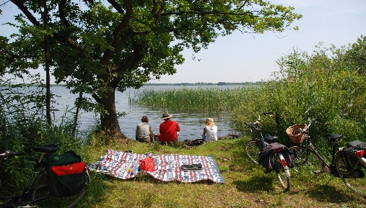

Car of the Month

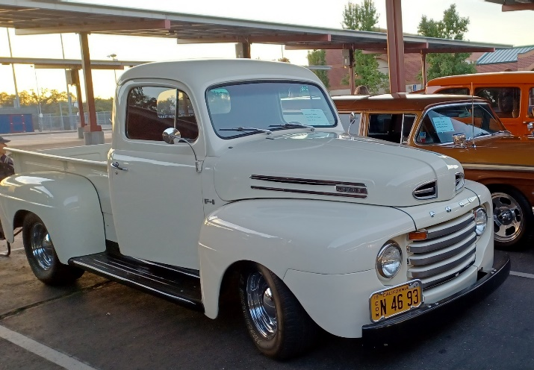

Jerry & Judy Lucas’ F1

Ladies Luncheon March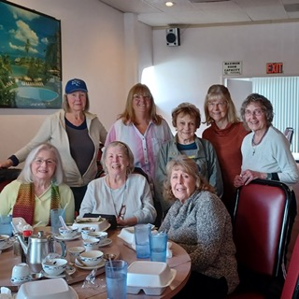

The ladies luncheon was held at China City with 8 members in attendance. Discussed Sandra’s outpatient toe surgery. Bud and Judi trip to LA, along with the completion of their gazebo. Sandy gave us an update on her move to Rancho Cordova, happy for her. Michelle shared that Trader Joe’s maybe making its way up the hill. Can’t wait. The food was great with lots of leftovers. Looking forward to next time.

Meeting April

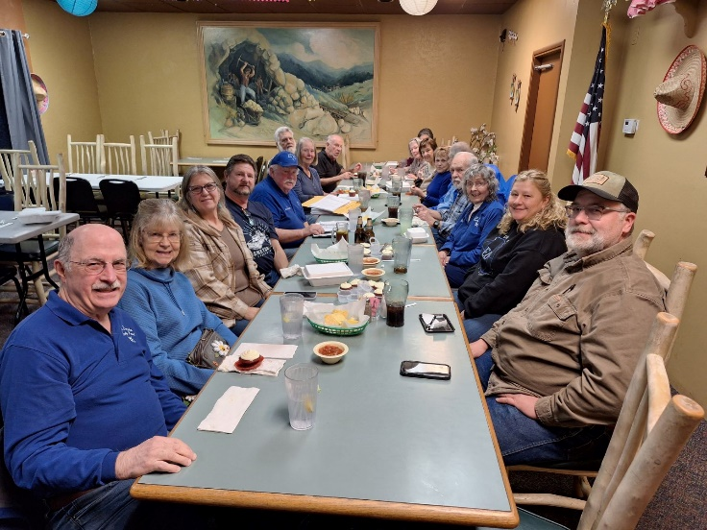

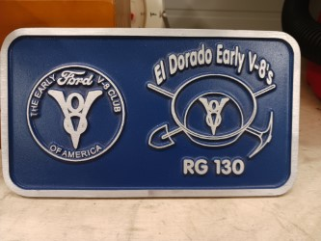

Contact Jerry Lucas or Dean if you would like to purchase 1.
$27.50 is what Jerry paid for them in a lot of 10 he's only asking what he paid.

Men’s Luncheon

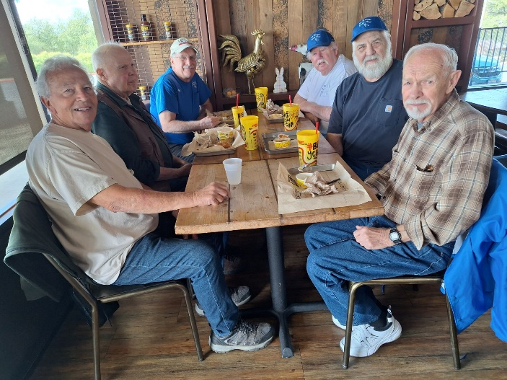

There were 6 members who made the men’s luncheon at Diskey’s BBQ. The group had a good time with lots of stories about local cops in the good old days. Discussed home insurance cost, car shows, and Dean making sure Dave was keeping his gas pump waxed.

Hardie’s Car for Sale

I sadly am offering my ‘35 Ford PU for sale which I’ve had since 1989.
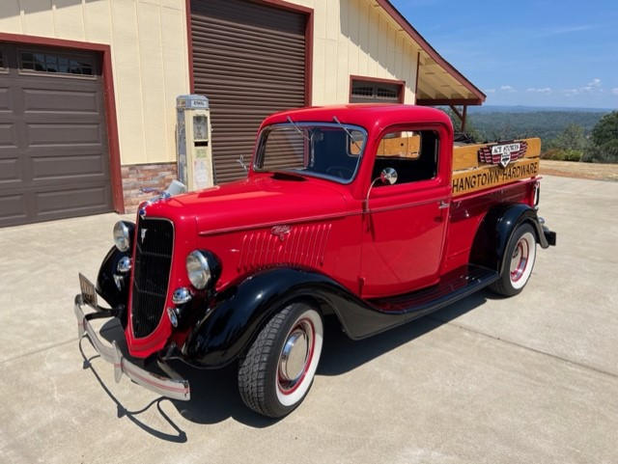

The 1st restoration was completed in 1997 with a Flathead/C4 auto. I upgraded in 2006 to a Hipo Cobra 289 and more. The engine is a Hipo mechanical lifter 289 out of an original Shelby small body Cobra. The trans is still a Ford C4. Rear end is Ford 9”, I think 3.70 gearing. In 2006 I upgraded the front end to disc brakes & mono leaf spring. The rear has twin parallel leaf springs. If anyone is interested, please have them contact me for more detailed info. I am asking $55K
Art Hardie 530-409-5120 hangtownace@sbcglobal.net
Sunshine Sunshine


March 2024 Just heard back from Jim Moore. He isn't feeling well. He was tested for Covid and RSV and those were negative. As it turns out it is a bacterial infection, and he is taking strong antibiotics. He is resting at home.

Wanted
I'm looking for a '51 Victoria steering wheel that is usable. A few small cracks won’t matter if the overall structure is good. J.B. Weld is standing by. Email BillwV8@yahoo.com Thanks, Bill Wilson

Thank you, Kim Hopwood,
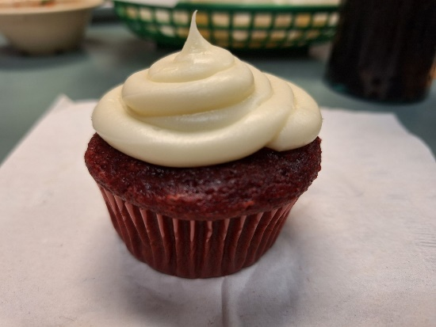
Wonderful cupcakes. Nice surprise she made and shared to celebrate March birthdays. Yum

Got something to sell? Post it here for free.

Pretty picture filler spacer



